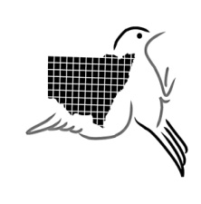**NSW Bird** Atlassers Inc Treasurer

A group monitoring birds in New South Wales PO Box 717 Woolgoolga NSW 2456

WEB: [www.nswbirdatlassers.org.au](http://www.nswbirdatlassers.org.au) P: 02 6654 8447

E:[treasurer@nswbirdatlassers.org.au](mailto:treasurer@nswbirdatlassers.org.au)

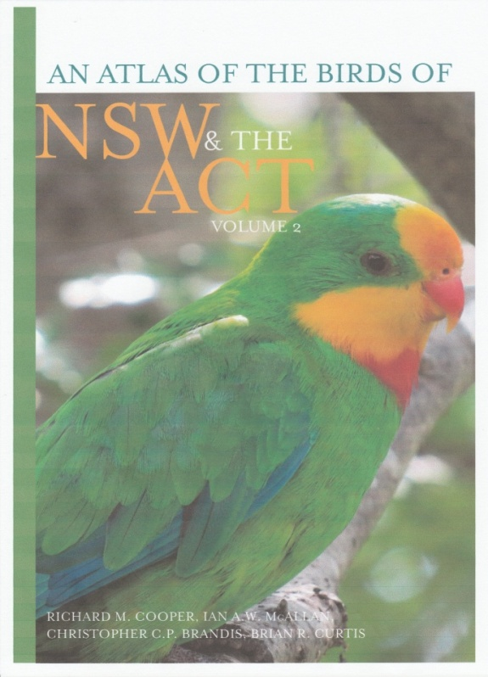**An Atlas of the Birds of NSW & the ACT:Volume 2** Richard M Cooper, Ian AW McAllan, Christopher CP Brandis, Brian R Curtis.

This, the second of 3 Volumes, contains over 670 pages covering 165 resident and migratory species from the Comb-crested Jacana to Striated Pardalote. Details for each species include current distribution, breeding biology and seasons, variations in seasonal and historic range and current status and trends.

**The Recommended Retail Price of Volume 2 is $135.**

In 2016, Volume 2 was submitted to The Royal Zoological Society of NSW Whitely awards.

‘’When Volume 3 is finished, this mighty effort by a small, dedicated bunch of amateur ornithologists, will have culminated in over 2000 pages of published mapping and analysis of the distribution of every Australian bird species found in NSW and the ACT. Importantly, over a 40 year span, a continuous record at the 10-minute block scale has been published”

*Julian Reid*, Cowra Comments July 2016.

‘’...It’s a wonderful Atlas—jam-packed with useful information which should be welcomed by ornithologists and recreational birdwatchers alike’’

*John Peter*, Australian birdlife, September 2016.

**Volume 1 of An Atlas of the Birds of NSW & the ACT is also available. RRP $135.**

Volume 1 covers the Emu to Plains-wanderer and is a world-leading Atlas presenting the results of long-term data collection at the fine scale of ten-minute blocks, thus providing an analysis against which future changes in bird distribution can be evaluated allowing effective conservation and habitat management.

In 2015, Volume 1 was submitted to the Royal Zoological Society of NSW Whitley Awards, by invitation.

‘’An important biogeographic analysis appears in Volume 1 which covers all the indicative species of NSW and the ACT. For those of you who, like me, love poring over maps and appreciate detail, this series of books is for you’’.

*Julian Reid*, Cowra Comments July 2016.

**Payment Advice**

Please reserve for me.......copies of Volume 1 and.......copies of Volume 2

Plus $25 p&p for each copy. Total payment: $.....................

**Payment** may be made direct to the NSW Bird Atlassers account:

**EFT**- NSWBA- BSB 704 328 account 200434, please include your name;

**Cheque**: payable to NSW Bird Atlassers and posted to the Treasurer above.

With either payment method, please return this Payment Advice or email [treasurer@nswbirdatlassers.org.au](mailto:treasurer@nswbirdatlassers.org.au) with your name and mailing address:

Print Name:.....................................................Phone:......................

Mailing address:..............................................................................