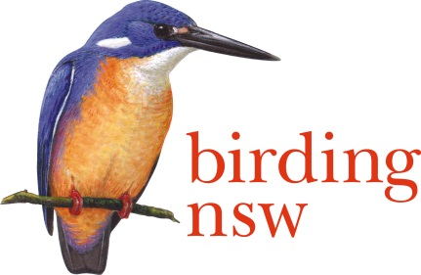
NSW Field Ornithologists Club Inc
ABN: 72 008 283 208
PO Box Q277 QVB Post Shop Sydney NSW 1230
Email: info@birdingnsw.org.au
Website: www.birdingnsw.org.au

The Director
NSW Department of Planning and Environment
Level 22, 320 Pitt St Sydney 2000

25 February 2017

Dear Sir or Madam,

RE: Ingleside Precinct Draft Structure Plan – an Objection.

On behalf of the Committee and 400 members of Birding NSW, I submit that we are
vehemently against any proposal to further develop the Ingleside Precinct. There is already substantial human intervention in the Sydney basin and the proposed clearing of land and building of 3,400 dwellings at Ingleside, Northern Beaches will degrade one of the remaining part-preserved ecosystems on the coast.

Please consider what exists in the area:
351 ha of the 700 ha is classed as native vegetation. The suburb is a hilltop location with creeks and streams providing a network of corridors and good habitat for fauna and flora. Amateur ornithologists will advise that where a substantial list of bird species exist there will also be many other unseen animals using the same food supplies. Insects, nectar, seed and small mammals provide the lower end of a healthy food chain.

Today on the eBird website, there are two data base hotspots recording what is present:
Chiltern Trail Ingleside, 102 species from 107 checklists, February 2010 to February 2017.
Ingleside Chase Reserve, 73 species from 5 surveys, Oct 2015 to January 2017.
Regardless of whether these reserves are included in the proposal or not, it is essential that corridors, buffer zones and nomadic species staging posts are retained.

While a dozen endangered bird species are listed in the Eco Logical Australia (2016) reports, what is just as important to us is that the iconic birds are preserved at the same time. Do the NSW DP&E and Northern Beaches LGA want to be the organizations responsible for the disappearance of Lyrebirds, Kookaburras, Magpies, Yellow-tailed Black-Cockatoos and Brush-turkeys?

Our bushland has huge Tourism value. Over future years, the Australian bush and its unique inhabitants will repay over and over the dollars spent on a one-off destruction of the leafy suburb.

Sincerely

Ian Bailey O.L.O.
Office of Conservation
Birding NSW CC Northern Beaches Council, Exec Committee BNSW.

