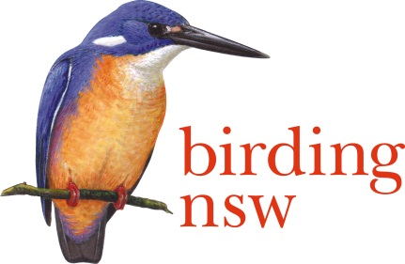
NSW Field Ornithologists Club Inc
ABN: 72 008 283 208
PO Box Q277 QVB Post Shop Sydney NSW 1230
Email: info@birdingnsw.org.au
Website: www.birdingnsw.org.au

The Hon Malcolm Turnbull MP
Prime Minister
Parliament House Canberra ACT 2600.

The Hon Will Hodgman MP
Premier of Tasmania
Level 11 15 Murray St Hobart Tas. 7000

The Hon Daniel Andrews MP
Premier of Victoria
1 Treasury Place Melbourne Vic. 3002

The Hon Jay Wetherill MP
Premier of South Australia
GPO Box 2343 Adelaide SA 5001
18 March 2017.

Dear Leaders,
RE: the Shooting of Waterfowl in Eastern Australia for Sport.

Once again this duck-shooting season 1,000s of birds will be shot for fun.
Not only the species allowed, but species which are endangered will be unnecessarily slaughtered.
During the 2016-17 waterbird breeding season, many species have had a chance to re-build their populations by virtue of the flooding of the Murray-Darling Basin. Shooters, therefore, will report great numbers of birds and assume there is not a problem.

Over 400 members of Birding NSW know that most of the individual waterbirds of the east and southern coastlines of Australia migrated to the breeding grounds and many are still there. We will never see them again if this carnage is not stopped.

Please stop the Annual Duck-Shooting Season.
One of our most valuable assets, our wildlife, must be preserved to build the tourism industry of this Nation as it is unique and irreplaceable.

Sincerely,
Ian Bailey.
Office of Conservation, Birding NSW.
CC: Committee.

