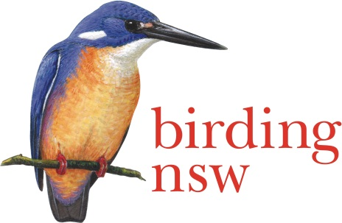
The NSW Field Ornithologists Club Inc
ABN 72 008 283 208
PO Box Q277 QVB Post Shop, Sydney NSW 1230
Email: info@birdingnsw.org.au
Website: www.birdingnsw.org.au

2016 Photographic Competition

ENTRY FORM
Photographer’s Name:…………………………………………………………………………………….
Telephone Numbers: (H)……………………………...….. (M)…………………..………………..
Email Address:……………………………………………………………………………..………………..
CATEGORY | SPECIES | DETAILS OF MODIFICATIONS (if any) | JUDGES USE ONLY

If you win a place in the Photographic Competition your winning photograph (properly acknowledged) will be published in the Birding NSW Website and/or in the newsletter
Mail to PO Box Q277, QVB Post Shop, Sydney, NSW 1230
(must be received by 30 September)

Or

Hand –deliver to a Club Committee Member at the September or October Club Meeting
Meetings are held on the first Tuesday of the month
Mitchell Theatre, Mechanics’ School of Arts
280 Pitt Street, Sydney
(closing date is October Club Meeting)
Rules Of The Birding NSW
Photographic Competition 2016
- Entry is open to all photographers, either financial members of Birding NSW ($40), or on payment of a $50 entrance fee
- All entries must be the entrant’s own work
- Photographs must be of native Australian birds taken in the wild in Australia or in its waters or territories
- There are three entry categories:
1 - single bird
2 - group of birds
3 – bird/s in flight
- No photograph or image will be accepted in which a next or a nest site is visible
- Each entrant may submit no more than three (3) images in any one category, for a total of not more than nine (9) images
- Images may be taken on digital or film camera, but those taken on film camera must be scanned onto a disk or USB drive
- Entries must be submitted on disk or USB drive and must include a completed entry form. No emailed entries will be accepted. Please ensure that your name is written on the disk or USB drive.
- Any form of modification to the images is allowed. However, the entrant must state whether the image has been modified or not, and give brief information about the nature of the modification
- Do not include your name or anything that may identify you on the images
- Competitors are required to submit their entries in standard.jpg format 1600 x 1024 pixels, and, in addition a smaller version of the entry for website publication (.jpg format and no larger than 300 KB)
- In submitting entries, competitors acknowledge the right of Birding NSW to publish the top 10 winning images in its newsletter and on its website
- No entrant can receive more than one prize
- The winner will receive $1,000 and the runner-up $500
- There will be three prizes of $250 each for the best entry in each of the three categories, apart from the two main prizes
- Criteria on which entries will be judged include photographic technique and composition, clarity of the bird(s) depicted, rarity of the species or apparent difficulty in obtaining the shot and overall visual impact
- The judges’ decision is final, and distribution of the prizes is at the discretion of the judges, who reserve the right not to award a prize if the entries are deemed not to be of a high enough standard
- The deadline for entries is Tuesday, 4 October. Results will be announced and prizes will be distributed at the 1 November meeting of Birding NSW, at 7:30 pm in the Mitchell Theatre, Level 1, Sydney Mechanics’ School of Arts, 280 Pitt Street, Sydney. Everyone is welcome to attend.

