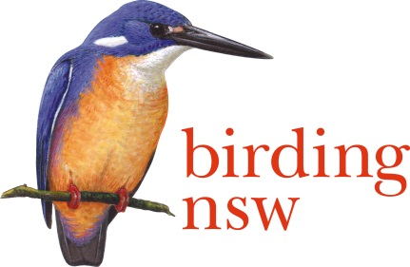
NSW Field Ornithologists Club Inc
ABN: 72 008 283 208
PO Box Q277 QVB Post Shop Sydney NSW 1230
Email: info@birdingnsw.org.au
Website: www.birdingnsw.org.au
NSW Regional Forest Agreements
DPI Forestry
Department of Primary Industries
GPO Box 5477 Sydney NSW 2001.

15 February 2018.

Dear Sir or Madam to whom it concerns,

RE: Regional Forest Agreements (RFA), an OBJECTION to renewals.

Considering that a great proportion of the original forests of NSW have been removed since white settlement, (an estimated 50-90% of vegetation classes in NSW, David, K, Ocean Shores to Desert Dunes, NPA, 2006) and considering also that once removed, old growth forest can never be replaced or regrown, it is time governments called a halt to logging in NSW forests.

The unique forests of NSW contain values that must be preserved. Apart from the natural ecosystem storage of carbon, water and habitat for thousands of flora and fauna, the current and future success of Tourism cannot be overestimated. It is time to say ‘’No’’ to the removal of native trees and bush. A mature tree (50 years plus, 30 cm in diameter or more) should not, must not, be cut down. Trees with hollows, more than 150 years old and many growing before that white settler arrived, are Cathedrals of Nature and should be treated as such. They can never ever be replaced.

Tourism in Australia will continue to expand for generations into the future. People will only travel half-way around the globe if we still have the old forests, shrubs, animals and beaches that are indigenous and irreplaceable. Imagine a NSW or Australia without Koala, Platypus, Kangaroo and Wallaby; a bush landscape without Wattle and Gumtrees? Our rich birdlife is also unique and very few species will survive if forests are depleted. Kookaburras nest in hollows. Lyrebirds scratch around in the leaf litter.

Does this generation want to be responsible for the destruction of the Australian landscape as we know it? We are already well down the track in doing that, especially in the Sydney Basin, and it is time we stopped.

On behalf of 400 members, we call on the NSW Government to halt logging and scrap Regional Forest Agreements.

Sincerely

Ian Bailey
Office of Conservation
Birding NSW

