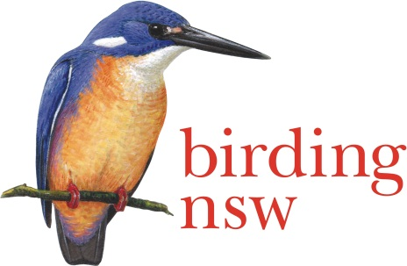
BIRDING NSW
ABN 72 008 283 208
PO Box Q277 QVB Post Shop, Sydney NSW 1230
Email: info@birdingnsw.org.au
Website: www.birdingnsw.org.au

2018 Photographic Competition

ENTRY FORM
Photographer’s Name:
Telephone Numbers: (H)……………………………...….. (M)…………………..………………..
Email Address:
For each photo, please supply the following details:
CATEGORY | SPECIES | DETAILS OF MODIFICATIONS (if any)

If you win a place in the Photographic Competition your winning photograph (properly acknowledged) will be published in the Birding NSW Website and/or in the newsletter
Mail a CD or USB of your images with the completed entry form to
PO Box Q277, QVB Post Shop, Sydney, NSW 1230 to arrive before 25 September 2018

OR

Hand – deliver your CD or USB to a Committee Member
at the August or September Meeting of Birding NSW
Meetings are held on the first Tuesday of the month at the Mitchell Theatre, Mechanics’ School of Arts, 280 Pitt Street, Sydney

Birding NSW Photographic Competition 2018 Rules
- There is an entry fee of $20 for photographers who are not financial members of Birding NSW.
Pay through online banking: Account name: Birding NSW, BSB: 062 169, Acct. No. 10193174, Reference: Your surname, OR pay by cheque payable to “Birding NSW” and posted to the address at the top of the entry form, together with a copy of the form.
- All entries must be the entrant’s own work.
- Photographs must be of native Australian birds taken in the wild in Australia or in its waters or territories.
- There are three entry categories:
1 - single bird, 2 - group of birds or 3 – bird/s in flight
- No photograph or image will be accepted in which a nest or a nest site is visible.
- Each entrant may submit no more than three (3) images in any one category, for a total of no more than nine (9) images.
- Images may be taken on digital or film camera but those taken on film camera must be scanned onto a disk or USB drive.
- Entries must be submitted on disk or USB drive and must be accompanied by a completed entry form. No emailed entries will be accepted. Please ensure that your name is written on the disk or USB drive.
- Any form of modification to the images is allowed. However, the entrant must state whether the image has been modified or not and give brief information about the nature of the modification.
- Do not include your name or anything that may identify you on the images.
- Competitors are required to submit their entries in standard.jpg format 1600 x 1024 pixels, and, in addition, a smaller version of the entry for website publication (.jpg format and no larger than 300 KB).
- In submitting entries, competitors acknowledge the right of Birding NSW to publish the top 10 winning images in its newsletter and on its website.
- No entrant can receive more than one prize.
- The winner will receive $500 and the runner-up $250.
- There will be three prizes of $100 each for the best entry in each of the three categories, apart from the two main prizes.
- Criteria on which entries will be judged include photographic technique and composition, clarity of the bird(s) depicted, rarity of the species or apparent difficulty in obtaining the shot and overall visual impact.
- The judges’ decision is final and distribution of the prizes is at the discretion of the judges, who reserve the right not to award a prize if the entries are deemed not to be of a high enough standard.
- The deadline for all entries is 17:00 pm on Tuesday 25 September. Entries may be submitted at the August or September meetings of Birding NSW.
- All images will be shown, the results announced and the prizes distributed at the 7 November meeting of Birding NSW, at 7:30 pm in the Mitchell Theatre, Level 1, Sydney Mechanics’ School of Arts, 280 Pitt Street, Sydney. Everyone is welcome to attend.

