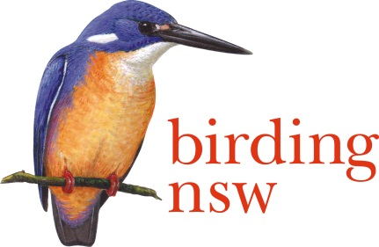
Birding NSW Inc
ABN: 72 008 283 208
PO Box Q277 QVB Post Shop Sydney NSW 1230
Email: info@birdingnsw.org.au
Website: www.birdingnsw.org.au

The Hon Stuart Ayres MP Minister for Western Sydney
By Email: penrith@parliament.nsw.gov.au

27 November 2018.

Dear Minister,

RE: The proposed raising of the Wall of Warragamba Dam.

I write to record our objection to this proposal on behalf of 415 members of Birding NSW Inc
Losses to ecosystems, flora and fauna, downstream riparian assets and rare species such as the Critically Endangered Regent Honeyeater recently found breeding in the area, tip the balance of environment protection to ‘’strongly negative’’.

If the raising of the wall goes ahead:
- thousands of hectares of the Blue Mountains National Park will be lost as water levels rise. Tourists come to NSW in their millions to witness The Blue Mountain’s iconic biodiversity.

- the surface area of the Lake Burragorang will increase allowing a greater collection of waste and fuel residues caused by the nearby Badgerys Creek Airport.

- downstream from the dam, creeks and rivers will continue to fail without the environmental flows to sustain frogs, fish and waterbirds.

The predicted mitigation of floods in the Sydney Basin will only be temporary and could lead to a disaster on the scale of a tsunami. A 100 year flood (25 years overdue), will still fill the dam, water will have to be released, and vast areas of built infrastructure to house the huge planned population will be flooded. We are already seeing evidence of rapid water run-off with minimal rainfall events.

If the raising of the wall goes ahead, Sydney will become a flood-risk zone of mammoth proportions. The Dam, Badgerys Creek Airport, vast areas of side-by-side roofing and few reserves to act as absorbent wetlands will ensure an inundation like nothing we have yet seen.

The State and Federal Governments should think very carefully about the need to increase the capacity of this dam. A severe drought in the 2000s when Warragamba Dam fell to 36% of capacity, led to us build a desalination plant which has hardly been used. The dam refilled. There is no need for water security.

We write to you, Honourable Ministers of State of NSW and Australia, in the hope that this issue will be debated more thoroughly in our Parliaments. It is not a matter to be decided upon by one Minister.

Birding NSW calls for a re-think of this plan. Please consider carefully the potential destruction of valuable bushland and the loss of habitat for endangered bird, animal and plant species.

Sincerely,

Ian G Bailey
Office of Conservation
Birding NSW inc.
Addressed to The Hon Stuart Ayres Minister for Western Sydney
CC
The Prime Minister of Australia the Hon Scott Morrison
The Hon Mellisa Price MP Minister for the Environment
Premier Berejiklian, Parliament of NSW
The Hon Anthony Roberts MP, Minister for Planning
The Hon Gabrielle Upton MP, Minister for the Environment NSW
Mr. Michael Daley Leader of the Opposition
Wollondilly Council.

