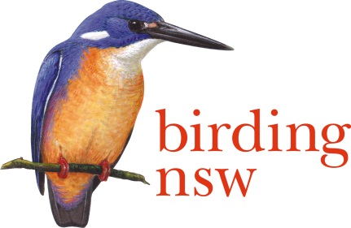
NSW Field Ornithologists Club Inc
ABN: 72 008 283 208
PO Box Q277 QVB Post Shop Sydney NSW 1230
Email: info@birdingnsw.org.au
Website: www.birdingnsw.org.au

MEMBERSHIP APPLICATION FORM
For Postal Membership Applications

Subscriptions are paid annually and are due on 1 October.
Members joining after 1 July in any year are credited with paying for the succeeding year.

Type of Membership
Please tick your category

- Single Adult Newsletter Online $40
- Single Adult Newsletter Paper Posted $45
- Family/Couple Newsletter Online $45
- Family/Couple Newsletter Paper Posted $50
- Junior (under 18 years) Newsletter Online $15

Applicant details
Family Name
Preferred Given Name
Address
City/Suburb |  |  | State |  | Postcode
Email
Phone | Mobile |  | Home
Other members' names
(for Family/Couples)

Payment Total
Membership |  |  | $______
Donation to Club |  |  | $______
Name Tag ($11.20, incl. postage) | No. |  | $______
Badge ($6.00, incl. postage) | No. |  | $______
 | Total |  | $_______

Method of payment
1. Post this form to the address at the top of this page with a cheque payable to 'Birding NSW'

2. Post this form to the address at the top of the page and pay through online banking:
Account Name: Birding NSW
BSB: 062169
Account No: 10193174
Reference/Description: your family name

